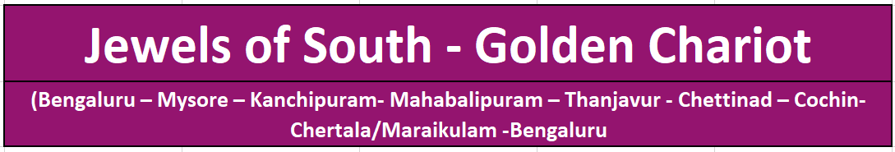

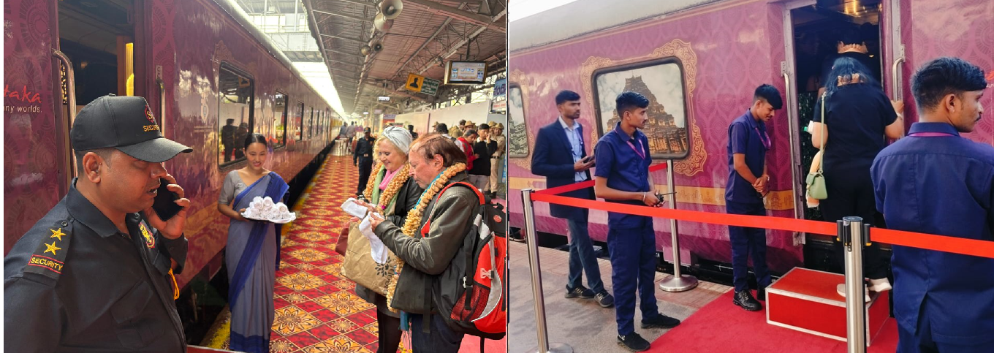
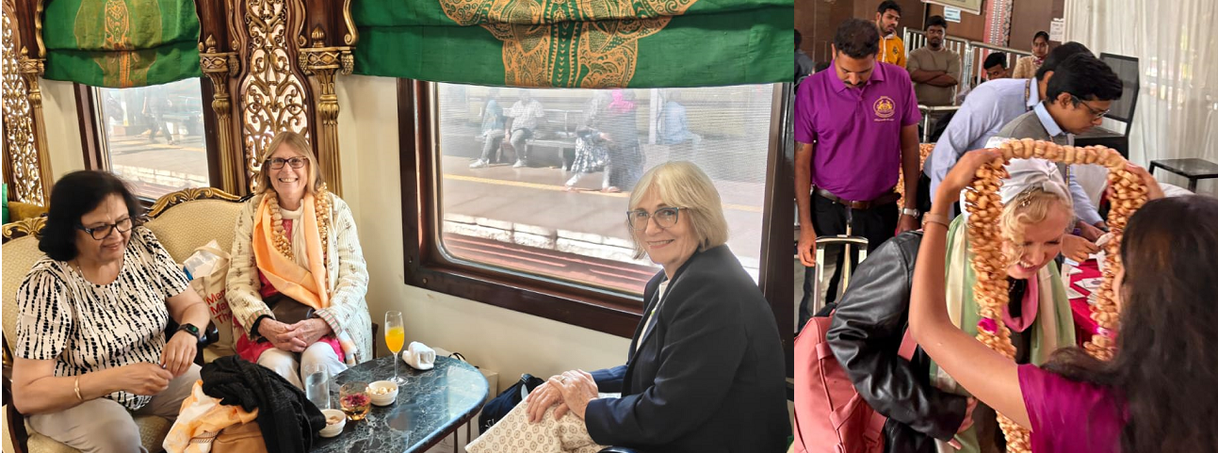
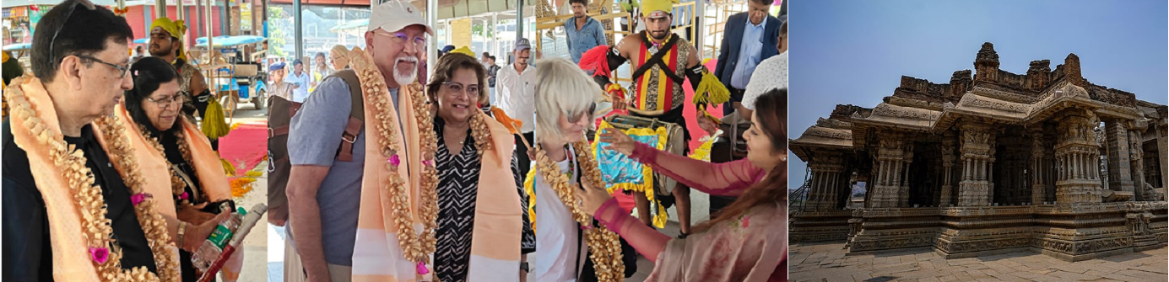

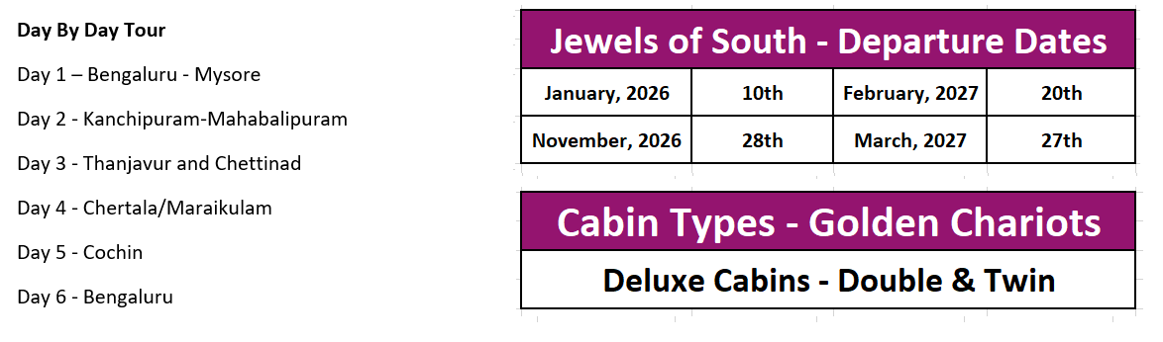

Jewels of South - Golden Chariot
Cabin Type | Published Tariff | Special Offer
Deluxe (2026 - 27) | USD 10500 | Contact Us
(For 02 Adults, Including Taxes, 05 Nights 06 Day Tour in a Deluxe Cabin)
Bangalore Tour - USD 588
01 Night Five Star Hotel Accommodation in Bangalore for 02 Adults including Breakfast & Taxes
All Local Transfers in Bangalore, Including Airport, Hotel, Railway Station Transfers by AC Car
01 Full Day Bangalore Sightseeing Tour by AC Car &English Speaking Guide with Monument Fee

Day 1 (Bengaluru to Mysore)
Arrive at Yeshwanthpur Railway Station (YPR) around 09:30 AM. Train departs at 10:30 AM.
Proceed to Mysore after welcome and registration. Lunch shall be served on-board. Proceed to visit the Mysore Palace at around 3:00 PM. Mysore Palace, also known as Amba Vilas Palace, is a historical palace and a royal residence. It is located in Mysore, Karnataka, India.Return to the train for dinner as the train proceeds to Chengalpattu.

Day 2 (Kanchipuram-Mahabalipuram)
Enjoy a relaxed breakfast on-board as the train arrives into Chengalpattu Railway Station.
Forenoon optional excursion to Kanchipuram followed by lunch at beachfront hotel. Visit to Mahabalipuram monuments .Mahabalipuram, is a town on a strip of land between the Bay of Bengal and the Great Salt Lake, in the south Indian state of Tamil Nadu. It’s known for its temples and monuments built by the Pallava dynasty in the 7th and 8th centuries. Lunch at beachfront hotel. Return to the train for dinner and proceed to Thanjavur.

Day 3 (Thanjavur and Chettinad)
Proceed to visit the UNESCO World Heritage Site - Brihadeshvara Temple. Brihadishvara Temple, called Rajarajesvaram by its builder, and known locally as ThanjaiPeriyaKovil and PeruvudaiyarKovil, is a Shaivite Hindu temple built in a Chola architectural style located on the south bank of the Cauvery river in Thanjavur, Tamil Nadu, India.Lunch shall be served on-board as the train proceeds to Chettinad. Visit the Athnagudi tile factory followed by visit to Chettinadu mansions. Dinner shall be served on-board as the train proceeds to Cochin.

Day 4 (Cochin)
After on-board breakfast, proceed to visit the Matancherry Palace in Fort Cochin area after which witness some of the best kept dance forms of Kerala at an exclusive venue.TheMattancherry Palace is a palace popularly known as the Dutch Palace, in Mattancherry. Return to the train for lunch. Enjoy an India evening on-board followed by dinner.

Day 5(Chertala/Maraikulam)
Cherthala is a municipality in the Alappuzha district of Kerala, India and act as satellite town of kochi. It is located 20 km north of the district headquarters in Alappuzha.Breakfast shall be served on-board followed by visit to houseboat cruise. Lunch will be served at exclusive venue .Return to the train evening followed by dinner Onboard.

Day 6(Bengaluru)
Breakfast shall be served on-board as the train arrives into KSR Bengaluru City Junction (SBC) Railway Station. Deboard at 0930 hrs as the journey ends.

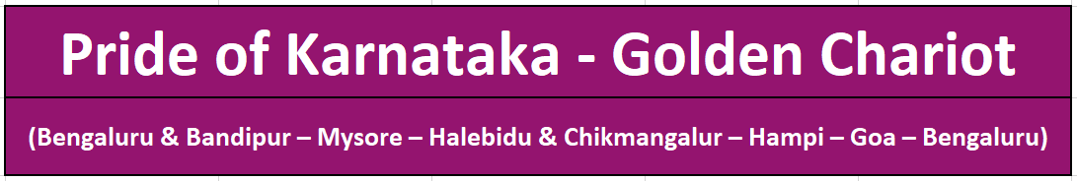

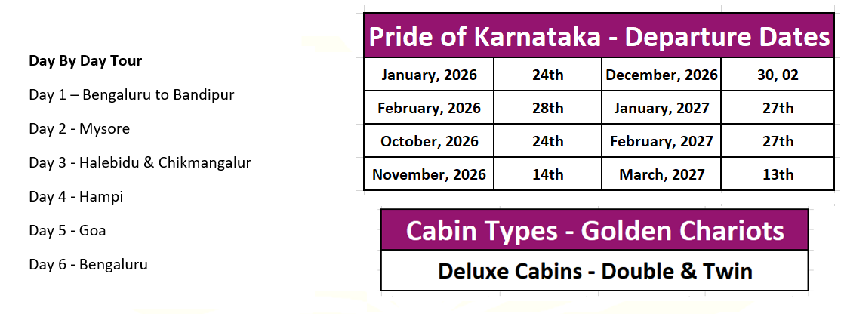
Pride of Karnataka - Golden Chariot
Cabin Type | Official MRP | Special Offer
Deluxe (2026 - 27) | USD 10500 | Contact Us
(For 02 Adults, Including Taxes, 05 Nights 06 Day Tour in a Deluxe Cabin)
Bangalore Tour - USD 588
01 Night Five Star Hotel Accommodation in Bangalore for 02 Adults including Breakfast & Taxes
All Local Transfers in Bangalore, Including Airport, Hotel, Railway Station Transfers by AC Car
01 Full Day Bangalore Sightseeing Tour by AC Car &English Speaking Guide with Monument Fee

Day 1 - (Bengaluru to Bandipur)
Arrive at SBC / KSR Railway Station at around 09:45 AM. Proceed on a fabulous journey at 11:00 AM after welcome and registration .Lunch shall be served On-board. Proceed for a game at Bandipur National Park from Nanjangud Town, approx. 50 km from Bandipur. Bandipur National Park, an 874-sq.-km forested reserve, is known for its small population of tigers,also harbors Indian elephants, spotted deer, gaurs (bison), antelopes and other native species

Day 2 (Mysore)
After breakfast on-board, proceed to visit the Mysore Palace. Mysore Palace, also known as Amba Vilas Palace, is a historical palace and a royal residence. It used to be the official residence of the Wadiyar dynasty and the seat of the Kingdom of Mysore. The palace is in the centre of Mysore, and faces the Chamundi Hills eastward.Return to the train for lunch.

Day 3 - (Halebidu & Chikmangalur)
After On-board breakfast proceed to visit the Hoyasaleshwar Temple at Halebidu. Hoysaleswara temple, also referred simply as the Halebidu temple, is a 12th-century Hindu temple dedicated to the god Shiva. It is the largest monument in Halebidu, India and the former capital of the Hoysala Empire Enjoy lunch as the train proceed towards Chikmangalur.In the evening visit a plantation resort and enjoy dinner with cultural activities

Day 4 (Hampi)
After breakfast on-board, proceed to visit the capital of Vijayanagara kingdom – Hampi.
A UNESCO World Heritage site, the ruins at Hampi tell a tale of opulence and grandeur of the kingdom also known as kishkindha in the Ramayana age is a town in the Vijayanagara district in the Indian state of Karnataka.Return to the train for lunch. In the evening relax on-board.

Day 5 - (Goa)
After on-board breakfast proceed to visit the churches of North Goa. The Basilica of Bom Jesus is a Catholic basilica, the iconic church is a pilgrimage centre and recognised by UNESCO as a World Heritage Site. The basilica is located in Old Goa, the former capital of Portuguese India, and holds the mortal remains of St Francis Xavier. Return to the train for Lunch.In the evening proceed for an exhilarating evening of Goan music and dance followed by Dinner.

Day 6 (Bengaluru)
Breakfast shall be served on-board as the train arrives into SBC/KSR Railway Station at around 11:30 AM. Deboard as the journey ends.

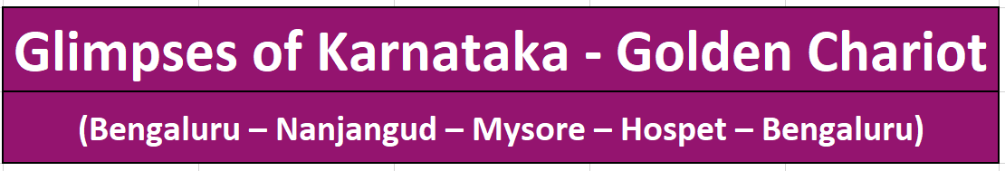

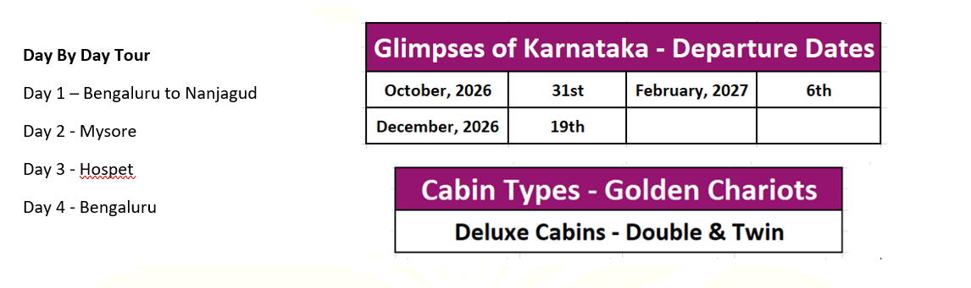

Glimpses of Karanataka - Golden Chariot
Cabin Type | Official MRP | Special Offer
Deluxe (2026 - 27) | USD 7140 | Contact Us
(For 02 Adults, Including Taxes, 03 Nights/04 Day Tour in a Deluxe Cabin)
Bangalore Tour - USD 588
01 Night Five Star Hotel Accommodation in Bangalore for 02 Adults including Breakfast & Taxes
All Local Transfers in Bangalore, Including Airport, Hotel, Railway Station Transfers by AC Car
01 Full Day Bangalore Sightseeing Tour by AC Car &English Speaking Guide with Monument Fee

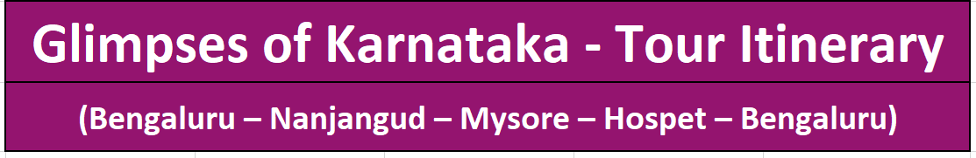

Day 1 / Saturday (Bengaluru to Nanjangud)
Registration and Check in from 08:30 hrs onwards
Morning departure from YPR (09:45 hrs).
Lunch onboard as train arrives into Nanjangud. (13:30 hrs)
Evening Safari (16:30 hrs to 18:30 hrs).
Return to train by 20:15 hrs. and dinner onboard as train proceeds to Mysore.
Overnight on the train at Mysore.

Day 2 / Sunday (Mysore)
Breakfast onboard.
Proceed to visit Mysore Palace.
Return to train for lunch after which optional visit to Srirangapatnam.
Dinner onboard as train proceeds to Hospet (20:00 hrs), watering and fuelling.

Day 3 / Monday (Hospet)
Breakfast onboard.
Visit Hampi ruins
Lunch onboard.
Evening free.
Dinner onboard.
Train proceeds to Bengaluru

Day 4 / Tuesday (Bengaluru)
Breakfast onboard.
Deboard at Bengaluru (YPR)

“Tour end with memories”

GOLDEN CHARIOT INCLUSIONS:

- Accommodation in double / twin bedded cabins with en suite bathrooms.
- All meals, soft beverages, house brands of Indian wines, beer and spirits.
- Butler service.
- guided off train excursions as illustrated in the journeys inclusive of entrance fees, still camera fee, transport and services of a guide.
- Complimentary tea, coffee and packaged drinking water on board.
- Porterage at stations.
- Services of Paramedic On-board.
- For guests booked in Deluxe Cabin, the transport would be a Volvo bus/Tempo traveller/Volkswagen crafter with a common English speaking guide depending on number of pax.

GOLDEN CHARIOT EXCLUSIONS:

- Any optional tours as mentioned in the itinerary.
- Insurance, Gratuities.
- Telephone calls, laundry, alcoholic beverages (apart from the house brands of wines, spirits, beer Served in the restaurants, bar and of board excursions).
- Video, film and professional still camera fees.
- Arrival and departure transfers.
- International and domestic air tickets.
- Pre and post tour accommodation and any tour extensions are not included unless specifically mentioned as part of the journeys.

IMPORTANT NOTE:
✓If Due to Covid19 Travel Restrictions Or Low Occupancy Or Any other reason, the Scheduled Depart does not Operate or cancelled by the operator, You Will be Informed At least One Week Before Scheduled Depart, And Have option to adjust advance in Future Journey or a similar value credit note valid for 60 months, or request for a refund of the same.
Train Operators reserve the right to amend any tariff / fee / itinerary / cancellations/ refund rules or any rules etc., and any difference in tariff or additional charges is to be paid by the guest only as per the operators rules,
International / USD (United States Dollars) Refunds - all refund amounts would be calculated on the basis of actual INR (Indian Rupee) value received and any foreign exchange value difference is to be borne by you. LUXURY INDIA shall not be responsible for any such fluctuation in International currency and actual INR receipt shall be taken as base for all calculations. Luxury India reserves to deduct MINIMUM USD 235 per person towards Bank Charges / documentation charges in case of International refunds.

HOW TO CONFIRM THE TOUR OR CONFIRMATION PROCESS:

THE PROCESS OF TOUR CONFIRMATION & COMMUNICATION

Step 01:
-Selection & Finalization of the tour.
-Filling up booking form (which will be shared with you, along with cancellation & terms)

- Kindly share Passport copies, to refer the name/ nationality/ passport number

Step 02:
-Process the advance payment 30 percent as per the invoice copy shared with you.
-If International flight ticket already arranged then share the details

Step 03:
After receiving the amount, you will receive the confirmation email & a letter from our end. Bifurcation of tour amount will also be shared (receiving and balance). Balance payment needs be to cleared atleast 95days prior to arrival.

Step 04:
If you still have any questions or would like to add anything, then kindly intimate us. We will check what are best possibility to bring the change (sometime thing will not fit in).

Step 05:
Clear balance payment 90days prior to arrival in India. After receiving balance payment, we will share the reciept email for the same.

Step 06:
On closer date or one week prior, we will share the arrival assistance details which say who will meet you at the airport & assigned guest relations manager.

GENERAL TOUR CANCELLATIONS:

- 80 days or more prior to tour departure, 35% of Published Ticket Tariff is NON-refundable

- 79 – 65 days before departure 60% is of Published Ticket Tariff is NON- refundable
- 64 Days& Less before departure 100 % of Published Ticket Tariff is NON-refundable

All Cancellation mails must be received and acknowledged by us in writing

Christmas, New Year, and Signature journey charges

Additional USD 400 per head is charged as supplement charges for itineraries covering Christmas, New Year & all Signature Journeys. The charge is also applicable for child between 05-12 years.

Child Policy

Children below the age of 5 years are free to board the train, provided they share a bed with their parent (applicable only when double bed cabins are available).

Children between 5 and 12 years will be charged 50% of total price. Children have to accompany with two adults (applicable only when double bed cabin available).

In case of separate cabins, children are charged 50% of total cost and supplement charges.

In case of travelling with two children above five years, a separate cabin is provided with twin-sharing bed for 50% of adult cost for each child.

In case of travelling with three children above age of 5, separate cabin is given with double bed with 50% of adult fare for each child.

In certain cases, two children can stay in one cabin (50% of adult fare), and the third can stay in separate cabin with 50% of total fare and supplement charges.

If one adult and one child above five years choose to stay in separate cabin, the cost is calculated as two adult travelers.

If two children above five years choose to stay with one adult in a separate cabin, the children will be charged 50% of adult fare per head.

No show/ En route termination of tour/amendment:

If the guests fail to show up at the departure point, no refund or adjustment will be made.

If the tour is ended by the guest, the unused part of the itinerary will not be refunded or reused.

In case of no-show due to serious illness, IRCTC decides the matter of providing an alternative itinerary or date. No refund will be made. Such amendments are not possible in case of full train booking or charter train booking.

Important Note:
Train Operators reserve the right to amend any tariff / fee / itinerary / cancellations/ refund rules or any rules etc., and any difference in tariff or additional charges is to be paid by the guest only as per the operators rules,
General Rules :
IRCTC is the Train Tour Operator and Liability of Luxury India is limited to that of Booking Agent Only.

Cancellation rules to be applicable in case travel documents or pending payments not received as per booking terms & conditions.
In special case-where travel date of same passengers needs to be postponed to future specific dates, Minimum US$ 100 per person will be charged & subject to approval by IRCTC Authorities
In case of scheduled train tour depart is cancelled because of any reasons by Train tour operator (IRCTC), Guest will be informed at least one week before train depart & in such cases - Full amount received will be refunded or adjusted against any further travel services, (without any cancelation fee) to the Guest .
Luxury India CANNOT BE held liable to compensate for any additional Financial Loss caused viz Fee towards Cancellation of Air Tickets, Hotel Booking etc or if any Mental Trauma caused.
All foreign passport holders require valid indian Visa before boarding flight to india.
Request for refund due to refusal of Indian Visa will not be entertain Or Overseas passenger landing in India without proper travel documents-will be governed by cancellation rules.
No refund will be made in case of no-show Or self-curtailment of journey
Un-willingness to follow train tour as per schedule, will be non-refundable
At times, due to local logistics/ conditions, if Train tour Manager is forced to cancel certain scheduled sightseeing tours Or activities, at short notice - No refund will be made to passenger to compensate for this.
Request for train tour cancellation due to increase of taxes/tariff by IRCTC authorities will be governed by cancellation rules.
Where passenger makes request for refund due to self cancellation, it will be governed as per foreign exchange rules of RBI Bank and the process may take 6 to 8 weeks after documentention as per RBI guidlines& necessary approvals are received.
Luxury India reserves the right to charge MINIMUM US$ 100 per person as service charge & refund will be made as per INR Rupees amount received.

